Software Design Specification

Student-Faculty Interaction Platform

Version 1.0

PIYUSH JAISWAL
RAJJAT CHHAJER
PRIYAMWAD PATHAK
SOMYA PAREEK
Y SAI KRISHNA

1. Introduction

1.1 Purpose of this document

The purpose of this document is to describe the implementation of the Student-Faculty Interaction Platform . The Student-Faculty Interaction Platform is designed to provide feedback to the faculty from the students thereby improving the interaction. Various other features in our system also aim to improve the interaction even further.

1.2 Scope of the development project

This interaction system provides an online tool for faculties and students to interact in a much improved and better way. The faculty would be able to track efficiently the topics covered in a class and the student feedback which would give the faculty a better understanding of the intellectual status of a class regarding the subject. Many other features like request by student to meet the faculty, tracking of project progress would greatly improve the learning experience of the students.

1.3 Definitions, acronyms, and abbreviations

This is a comprehensive list of all the terms used in this document.

Course Handout: The list of various topics, subtopics and concepts to be taught in the course.

Faculty: The teacher teaching the corresponding courses.

HOD: The Head Of Department of a particular course.

Student: The pupils who are enrolled in a course and are taught by the respective faculty.

FUNCTION REQUIREMENTS:
REQ 1: View Course Handout
REQ 2: Update Course Handout
REQ 3: View Student Feedback
REQ 4: View Research or Specialization area of faculty
REQ 5: View meeting request
REQ 7: Give feedback for topics taught.
REQ 8: Schedule meeting or extra class.

1.4 References

None.

1.5 Overview of document

The rest of the SDS is organized in the following format:

2. System architecture description
Its various subsections describes the architecture of the Student-Faculty Interaction Platform.

2.1 Overview of modules / components
This subsection will introduce the various components and subsystems.

2.2 Structure and relationships
This subsection describes the various interrelationships and dependencies among the various components. Some diagrams are used to portray these features.

2.3 User interface issues
This section presents the main principles of the product's user interface. Technical details are not included in this section.

3. Detailed description of components
This section describes the various components of our platform.

3.1 Component template description
It is the pattern used to describe the components given in subsections 3.2 - 3.n. Each part of the template will be identified by a label.

3.2 View Course Handout Component
3.3 Courses enrolled in Component
3.4 Courses teaching Component
3.5 Course in-charge of Component
3.6 Topics and Subtopics Covered Component
3.7 Student feedback(frequency) Component
3.8 Giving feedback for topics covered Component
3.9 Faculty profile Component
3.10 Meeting Request Component
3.11 Notification Component
3.12 Edit Database Function
3.13 Check user Function

4.0 Reuse and relationships to other products
This section may include the following subsections as appropriate:
- how reuse is playing a role in your product design
- how reuse is playing a role in your product implementation (and the motivation for changes)
- if you are not reusing material that is available, then give motivation for why it is being thrown out.

5.0 Design decisions and tradeoffs
This section to motivates any decisions that will help the reader understand the design that our team is using. This section can also capture good ideas that were abandoned and the reasons for leaving them out of the design.

6.0 Pseudocode for components

7.0 Appendices

2. System architecture description

2.1 Overview of modules / components
The various modules and components in our software are:
- View Course handout
- Courses enrolled in
- Courses teaching
- Courses in-charge of
- Topics and subtopics covered
- Student feedback (frequency)
- Giving feedback for topics and subtopics covered
- Faculty profile
- Meeting requests
- Notifications
- Edit database
- Check user

2.2 Structure and relationships
The modules described above can be divided into two interfaces:

Home Page:
The basic landing page for our three different users. Specific users will have specific functionalities. Modules included:
- View Course handout
- Courses enrolled in
- Courses teaching
- Courses in-charge of
- Faculty profile
- Meeting requests
- Notifications

Course Handout
The course handout of a particular course. Modules included:
- Topics and subtopics covered (links included)
- Student feedback (frequency of feedback)
- Giving feedback for topics and subtopics covered

Database
All the data will be stored here. Modules included:
- Edit database
- Check user

Sequence Diagram
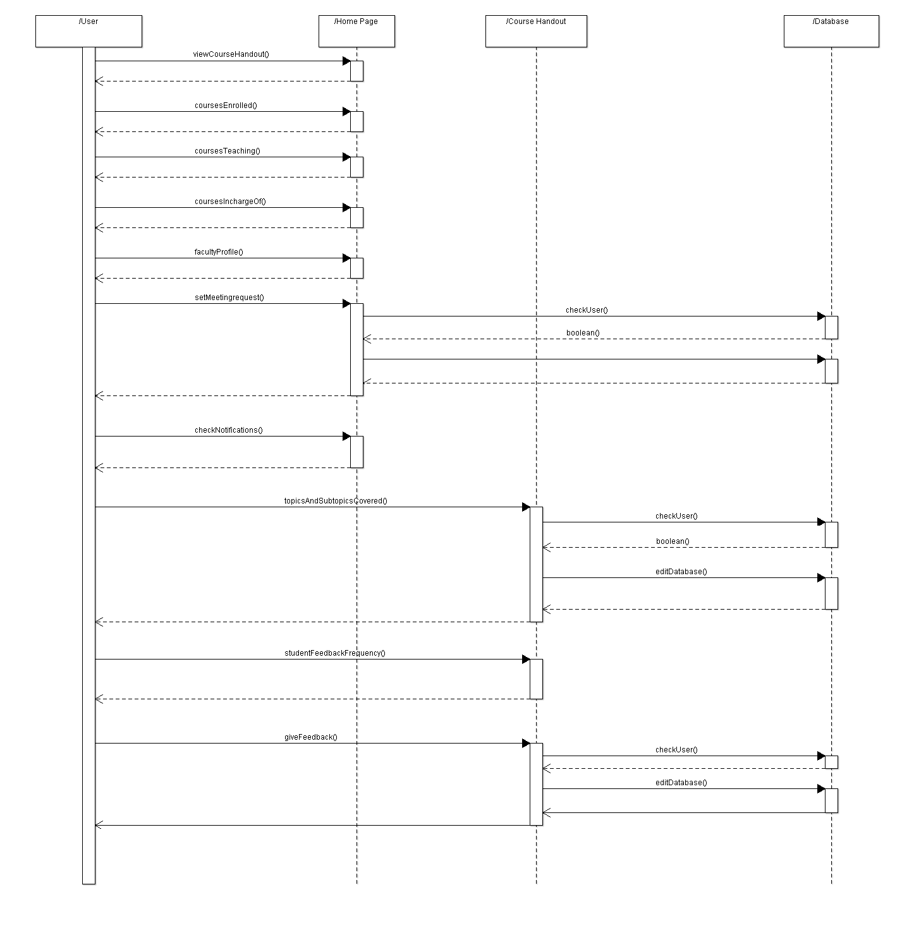

Description:
There are 4 general interfaces. The first one being the user. The second, third and fourth one being the Home Page, Course handout and Database respectively. There are modules which the user can access and some functions that are invoked because of it. The modules have already been described above. A brief overview of the sequence diagram is given below.

- User can view the course handout in the home page.
- On being directed to the home page, one of the three functions are invoked depending upon the user. Student invokes coursesEnrolled(), Faculty invokes coursesTeaching() and HOD invokes coursesIncharge().
- User can view the faculty profile, whose option is located in the Home Page.
- User can set the meeting request with other user classes in the Home Page. For this the checkUser() checks the user class and then enters the details of the meeting in the database with editDatabase().
- User can check his/her notifications in the home page.
- Faculty can edit the topics covered in the course handout. For this first the authenticity is checked and the database is edited accordingly.
- Faculty and HOD can view the frequency of the feedback if available in the home page.
- Students can give rating for the topics covered. The giveFeedback() function is invoked then. First the user class is checked and then the ratings are entered in the database.

Class diagram

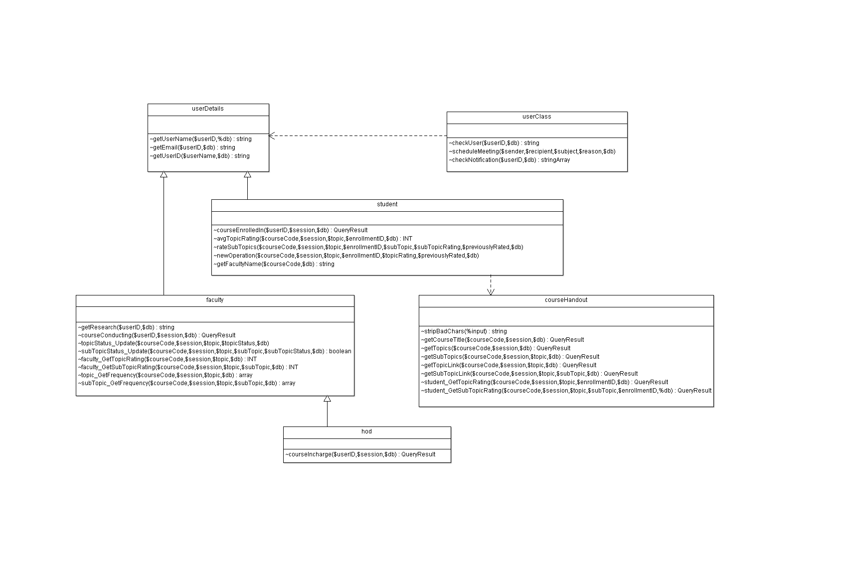

Description:
There are 4 main classes and three sub-classes.
The 4 main classes are :
- user
- homePage
- courseHandout
- database
The user class is divided into three subclasses: student, faculty and hod.

User can access both the courseHandout and the homePage. Certain functions in the courseHandout and the homePage require access to the database.

State diagram

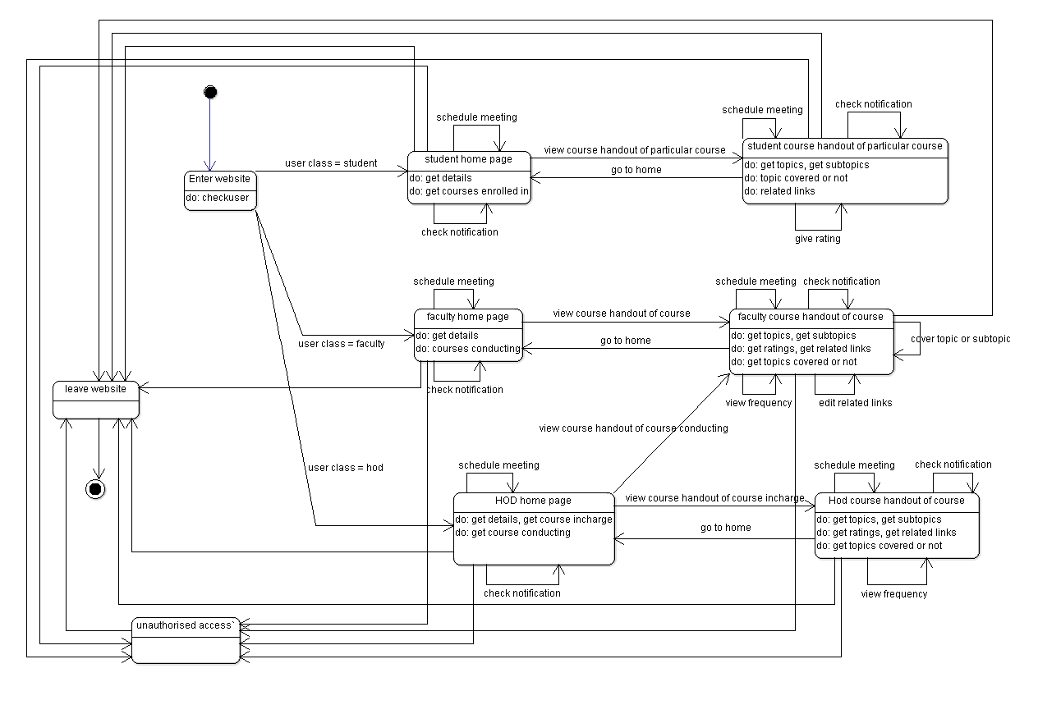

Description:

Each of student, faculty and hod have separate home and course handout pages. In each page they can view the notifications and schedule meetings. The course handout pages have different rights and features for each user class. Each user is redirected to an unauthorized page when detected or caught doing activities they do not have rights of. Our session ends when the user returns back to moodle.

2.3 User interface issues

- Or team had first though of including a logout button for the users but later decided to integrate it with moodle and hence the user now has an option to return to moodle.

- At first the student user could view the profiles of only the faculties of his enrolled courses.
The student user now can view profiles of all the registered faculties in order for him to approach the faculty in his/her field of interest.

3. Detailed description of components

3.1 Component template description

Identification | The unique name for the component and the location of the  component in the system.
Type | A module, a subprogram, a data file, a control procedure, a class, etc
Purpose | Function and performance requirements implemented by the design component, including derived requirements.
Function | What the component does, the transformation process, the specific inputs that are processed, the algorithms that are used, the outputs that are produced, where the data items are stored, and which data items are modified.
Subordinates | The functional requirements satisfied by each part.
Dependencies | How the component's function and performance relate to other  components. How this component is used by other components. The other components that use this component.
Interfaces | Description of interfaces. Error messages regarding the module.
Processing | The full description of the functions presented in the Function subsection.
Data | For the data internal to the component, describes the representation method, initial values, use, semantics, and format. This information will probably be recorded in the data dictionary.

3.2 View Course Handout Component

Identification | courseHandout
Type | module
Purpose | Views the course handout of a specific course.
Function | This component redirects the user to the corresponding course handout which was clicked. Depending upon the user, they will have different rights. Faculty will have the rights to update the topics covered and include related study links. Student will have the right to rate the topics as a feedback that have been covered by th faculty. HOD can just view the course handout just like Faculty, except he will not have the rights to update the topics.
Subordinates | REQ 1, REQ3,
Dependencies | courseEnrolled: if the student accesses it  courseTeaching: if the faculty accesses it.  courseIncharge: If the HOD accesses it.
Interfaces | In the Home Page interface.  Error messages:  Unauthorized access (by any of the user): If the student somehow views the course handout of the course he/she is not enrolled in.  Same for the faculty and the HOD for the courses he/she is not related to or currently conducting.
Processing | viewCourseHandout(course): Redirects to the corresponding course.
Data | Can access the database for the corresponding course.

3.3 Courses enrolled in Component

Identification | courseEnrolled
Type | function
Purpose | To access the courses the students are enrolled in.
Function | This function accesses the database and returns the corresponding courses a student is enrolled in.
Subordinates | REQ 1
Dependencies | None.
Interfaces | In the Home Page interface.  Error messages:  None as such as it just accesses the database internally for the corresponding courses of the student.
Processing | CourseEnrolled(): Internal function of the home page, activated when the student is directed here.
Data | Courses the student is enrolled in.

3.4 Courses teaching Component

Identification | courseTeaching
Type | function
Purpose | To access the courses the respective faculty is currently teaching.
Function | This function accesses the database and returns the corresponding courses a faculty is currently teaching.
Subordinates | REQ 1
Dependencies | None.
Interfaces | In the Home Page interface.  Error messages:  None as such as it just accesses the database internally for the corresponding courses of the student.
Processing | CourseTeaching(): Internal function of the home page, activated when the faculty is directed here.
Data | Courses the faculty is currently teaching.

3.5 Course in-charge of Component

Identification | courseIncharge
Type | function
Purpose | To access the courses the respective HOD is currently in-charge of.
Function | This function accesses the database and returns the corresponding courses a HOD is currently in-charge of.
Subordinates | REQ 1
Dependencies | None.
Interfaces | In the Home Page interface.  Error messages:  None as such as it just accesses the database internally for the corresponding courses of the student.
Processing | courseIncharge(): Internal function of the home page, activated when the HOD is directed here.
Data | Courses the HOD is currently in-charge of.

3.6 Topics and Subtopics Covered Component

Identification | topicsCovered
Type | module
Purpose | To update the topics, subtopics that have been covered in the classroom lectures or to update the related study links.
Function | This component updates the database according to the topics or subtopics covered or an edit of the study links. Access solely to faculty.
Subordinates | REQ 2
Dependencies | courseHandout: Redericted according to this module for the corresponding handout. Applicable only for faculty.
Interfaces | In the Course Handout interface.  Error messages:  Unauthorized access (by any of the user): If the student or HOD tries to somehow update it.
Processing | checkUser(): Checks the access rights of the user.  topicUpdate(): triggered if a topic is covered.  subtopicUpdate(): triggered if a subtopic is covered.  editLinks(): triggered if the related study links are to be updated.  editDatabase(): to edit the database.
Data | The data accessed by its related functions.

3.7 Student feedback(frequency) Component

Identification | frequencyFeedback
Type | module
Purpose | To view the frequency of the topics which have been rated by the students. Faculty and HOD have the rights to this.
Function | This component shows the frequency of the rating given by the students that have already been covered in class lectures.
Subordinates | REQ 3
Dependencies | courseHandout: Redericted according to this module for the corresponding handout. Applicable for faculty and HOD.  topicsCovered: Can view the frequency only for the topics covered.  studentFeedback: Can view the frequency only if the students have rated it.
Interfaces | In the Course Handout interface.  Error messages:  Unauthorized access: If the student tries to somehow access it.
Processing | checkUser(): Checks the access rights of the user.  feedbackFrequency(): views the frequency of the corresponding topic.
Data | The data accessed by its related functions.

3.8 Giving feedback for topics covered Component

Identification | studentFeedback
Type | module
Purpose | To enter the rating entered by a student for the corresponding topics or subtopics covered.
Function | This component enters the rating of the student entered corresponding to the topics or subtopics covered.
Subordinates | REQ 7
Dependencies | courseHandout: Redirected according to this module. Applicable only for student.  TopicsCovered: Can give rating only for the topics covered.
Interfaces | In the Course Handout interface.  Error messages:  Unauthorized access (by any of the user): If the faculty or HOD tries to somehow enter the rating.
Processing | checkUser(): Checks the access rights of the user.  giveFeedback(): Enter the corresponding rating.  editDatabase(): to edit the database.
Data | The data accessed by its related functions.

3.9 Faculty profile Component

Type | module
Purpose | To view the profile of a faculty or HOD.
Function | This component shows the profile of the faculties and HODs.
Subordinates | REQ 4
Dependencies | None.
Interfaces | In the Home Page interface.  Error messages:  None as such.
Processing | FacultyProfile(): shows the profile of the corresponding faculty or HOD.
Data | The data accessed by its related functions.

3.10 Meeting Request Component

Identification | meetingRequest
Type | module
Purpose | To request meetings with other user classes.
Function | This component is used for requesting meetings. A student may want to meet with the faculty or HOD and similarly for the respective faculties and HODs for meetings with others. Each meeting request is accompanied by the reason for the request.
Subordinates | REQ 8
Dependencies | None.
Interfaces | In the Home Page interface.  Error messages:  Not applicable: If one user class schedules meetings with the same user class.
Processing | SetMeetingRequest(): Contains the specific user and the reason for the meeting.  CheckUser(): Checks the rights of the user.  EditDatabase(): Edits the database.
Data | The data accessed by its related functions.

3.11 Notification Component

Identification | notification
Type | module
Purpose | To check important notifications if any.
Function | This component accesses the database and returns the impending notifications if any. Most importantly meeting requests are going to appear here. The user has the choice of accepting or rejecting. In case of accepting the time-slot for the meeting is entered.
Subordinates | REQ 8
Dependencies | MeetingRequest: Any meeting request
Interfaces | In the Home Page interface.  Error messages:  Wrong time-slot: If the time slot entered is not correct.
Processing | CheckNotifications(): Returns the notifictions if any. Currently the notifiactions include meeting requests.
Data | Data accessed by its functions.

3.12 Edit Database Function

Identification | editDatabase
Type | function
Purpose | For the modules and functions which require adding to or editing the existing database.
Function | This function edits the database according to the module which uses it.
Subordinates | REQ 2, REQ 7, REQ 8
Dependencies | TopicsCovered: Requires editing of the database in terms of topics cvered.  StudentFeedback: Requires editing of the database in terms of the ratings.  MeetingRequest: Requires editing the database in terms of requests for meetings.
Interfaces | In the Database interface.  Error messages:  None.
Processing | EditDatabase(): Edits the database.
Data | The data accessed by its related functions.

3.13 Check user Function

Identification | checkUser
Type | function
Purpose | For the modules and functions which require to check the authenticity of the user, particularly if a module edits the database.
Function | This component checks the authenticity and the rights of the user according to the modules.
Subordinates | REQ 2, REQ 7, REQ 8
Dependencies | FrequencyFeedback: Requires checking for faculty user class.  TopicsCovered: Requires checking for faculty user class.  StudentFeedback: Requires checking for student user class.  MeetingRequest: Checking for ineligibility of meeting requests for the same user class.
Interfaces | In the Database interface.  Error messages:  Not authorized: If the user does not have the required rights for the functionality.
Processing | checkUser(): Edits the database.
Data | The data accessed by its related functions.

4.0 Reuse and relationships to other products
Not applicable.

5.0 Design decisions and tradeoffs
Student-Faculty Interaction System design is basically a web platform wherein the faculty and the student can interact with each other and use its various functionalities. So it is basically a collection of webpages linked to each other to provide a good, simple and easy-to-understand experience. The various classes and functions in our system design is based on the functionalities provided in different webpages and thus having a simple layout.

6.0 Pseudocode for components

Note: This pseudocode might change drastically after the completion of the software.

View Course Handout Component
When the user clicks the view course handout option, the function viewCourseHandout() is triggered which checks the user class and redirects the course handout with the respective rights for student, faculty and HOD.

Courses enrolled in Component
This component is for the student user class only. Whenever the user redirects to the home page, the courses the user is enrolled in are showed to him by the courseEnrolled() function.

Courses teaching Component
This component is for the faculty user class only. Whenever the user redirects to the home page, the courses the user is currently teaching are showed to him by the courseTeaching() function.

Courses in-charge of Component
This component is for the HOD user class only. Whenever the user redirects to the home page, the courses the user is currently in-charge of are showed to him by the courseIncharge() function.

Topics and Subtopics Covered Component
This component is for the faculty user class. If a topic or subtopic is covered in the classroom lectures, the user ticks the corresponding topic in the course handout upon which first the checkUser() function is triggered for checking the rights of the user as this functionality will edit the database. Then depending upon the target clicked topicUpdate() or subtopicUpdate() are triggered and the respective topics or subtopics are available for the student to edit. If the user wants to edit the related study links the editLinks() function is triggered. After all this the respective data is entered in the database by the editDatabase() function.

Student feedback(frequency) Component
This component again is for the faculty class. The frequency of the ratings of the topics rated by the students is displayed by this event. First the checkUser() function checks the rights and then the feedbackFrequuency() function displays the frequency of the corresponding rating.

Giving feedback for topics covered Component
This component is for the student class. The user can rate the topics which have been covered. First the checkUser() checks the rights and then the giveFeedback() function takes the rating and finally the editDatabase() function enters the rating in the database.

Faculty profile Component
This component is for all the user classes. Any user can view the profiles of the faculties or HODs registered in our system. The facultyProfile() function displays the respective profile. The student profile cannot be seen as the ratings are to remain anonymous.

Meeting Request Component
This component is again for all the user classes but a user class can schedule meetings with other user classes only. The setMeetingRequest() function takes in the meeting recipient and the reason for the meeting parameters. The checkUser() checks the rights of the user for this case. The editDatabase() then enters the data in the database.

Notification Component
This component is available for all the user classes. Any meeting requests by the other user classes are displayed here. Any other important information would also be displayed here. The checkNotifications() functions checks if any notifications are pending for the user and displays them.

Edit Database Function
This function is triggered if a functionality edits data in the database. This function will be overloaded because different modules will call it all will be with different parameters. The different overloaded functions will edit different data of the database.

Check user Function
This function is called when the rights of the user class is to be checked. This is mostly triggered prior to editing the database. This function will have a target parameter in which the calling module will be stored and hence the corresponding rights for that module will be checked.

7.0 Appendices
None.

